**Experiment No # 05**

**Experiment Name # Process handling in Linux**

**Aim and Objects:**

## The Linux terminal has a number of useful commands that can display running processes, kill them, and change their priority level. An instance of a program is called Process. In this lab we will be able to how to handle process, kill process etc.

**Commands Use for Process Handling :**

## The commands for handling process in Linux is given below :

1. **Ps**

This command stands for 'Process Status'. It is similar to the "Task Manager" that pop-ups in a Windows Machine when we use Cntrl+Alt+Del. This command is similar to 'top' command but the information displayed is different.

To check all the processes running under a user, use the command -

1. **ps aux :** To display the owner of the processes along with the processes

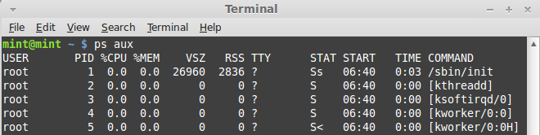

1. **ps ux :**

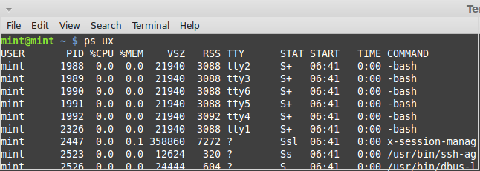

1. **ps –ag :** To get information about all running process

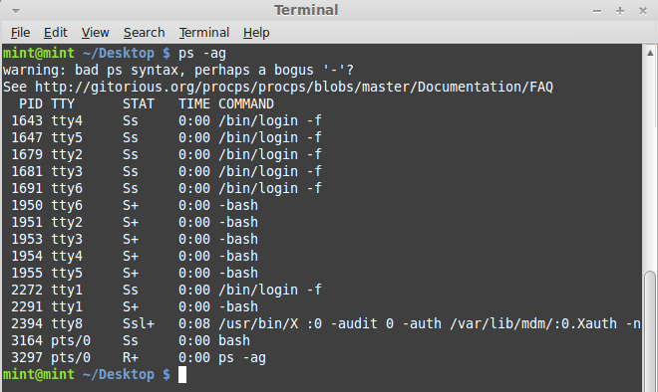

1. **pstree :** The **pstree** command is another way of visualizing processes. It displays them in tree format.

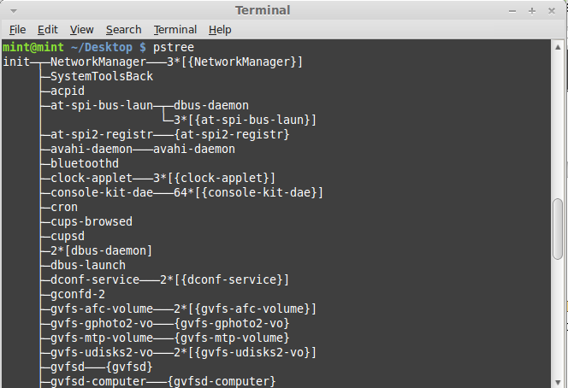

1. **Kill**

The **kill** command can kill a process. This command terminates running processes on a Linux machine.

To use these utilities I need to know the PID (process id) of the process I want to kill.

Example :

Kill PID:

Before Kill Command :

E:\ICT-3.1\OS\beforekill.png

Kill Command:



After Kill Command:

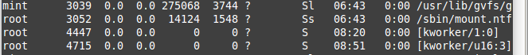

1. **Top**

This utility tells the user about all the running processes on the Linux machine

Example :

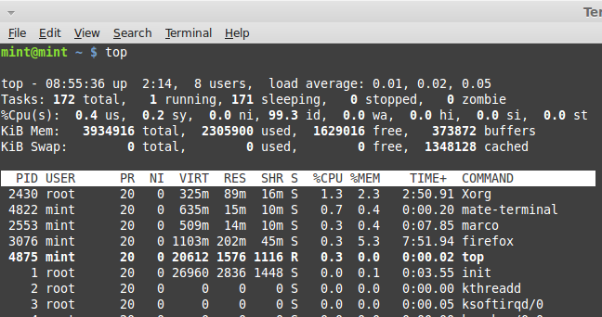

1. **df**

This utility reports the free disk space(Hard Disk) on all the file systems.

Example :

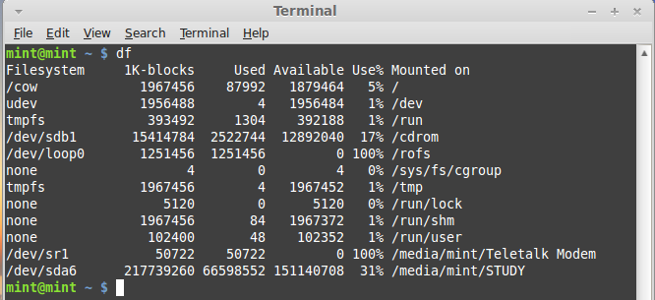

If we want the above information in a readable format, then use the command : df –h

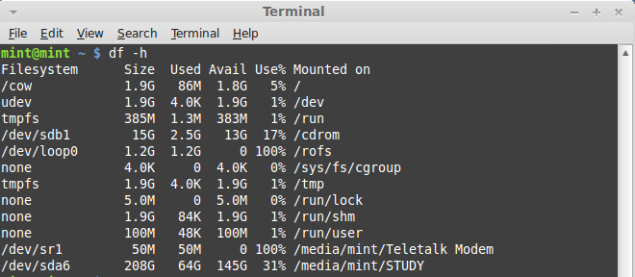

## Free

This command shows the free and used memory (RAM) on the Linux system.

free –m : to display output in MB

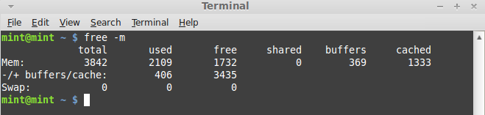

free –g : to display output in GB

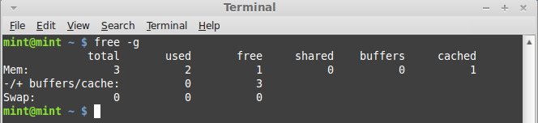

**Conclusion :**

The ps command on linux is one of the most basic commands for viewing the processes running on the system. It provides a snapshot of the current processes along with detailed information like user id, cpu usage, memory usage, command name etc. It does not display data in real time like top or htop commands. But even though being simpler in features and output it is still an essential process management/monitoring tool that every linux newbie should know about and learn well.